Here’s a clear bullet-point summary for EC2 Failed Status Checks:

⚡ EC2 Failed Status Checks
- Types of checks
  - System status checks → Monitor AWS infrastructure supporting the instance.
  - Instance status checks → Verify the instance itself is operating correctly.
- Accessing status checks
  - In the EC2 console, select the running instance.
  - Status checks section shows results:
    - System reachability check passed
    - Instance reachability check passed
- System status check failures
  - Causes: network connectivity issues, hardware problems, software issues on host machines.
  - Troubleshooting:
    - Check AWS Service Health Dashboard for outages.
    - Review AWS notifications.
    - Hardware issues are resolved by AWS teams.
- Instance status check failures
  - Causes: network connectivity, firewall rules, OS-level configurations (CPU, memory, storage).
  - Troubleshooting:
    - Reboot the instance.
    - Review logs for failure details.
    - Use Amazon CloudWatch to monitor CPU, network traffic, disk I/O, etc.
    - Validate system configurations.
    - Review security groups, network ACLs, and route tables.
    - Verify inbound/outbound rules for proper connectivity.
- Additional resources
  - AWS Documentation.
  - AWS re:Post community discussions.
  - Guides:
    - Status Checks for Your Instances
    - Troubleshoot Instances with Failed Status Checks
    - Why Is My EC2 Linux Instance Unreachable and Failing One or Both of Its Status Checks?
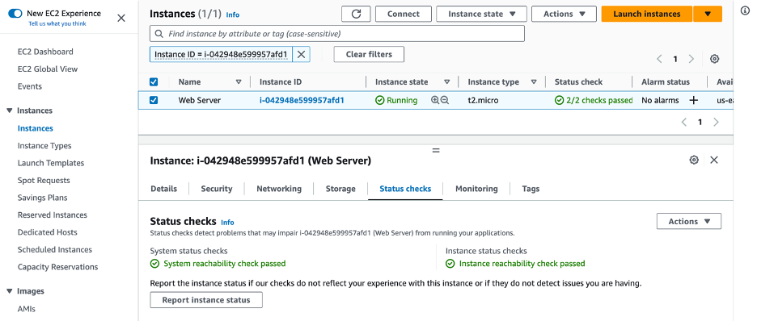
Here’s a troubleshooting flow diagram summary for EC2 failed status checks, structured into clear steps you can use in slides or study notes:

🔄 EC2 Failed Status Checks – Troubleshooting Flow
- Step 1: Identify the type of failure
  - System status check failed → AWS infrastructure issue.
  - Instance status check failed → Instance-level issue.
- Step 2: System status check troubleshooting
  - Check AWS Service Health Dashboard for outages.
  - Review AWS notifications.
  - Hardware/network issues → handled by AWS teams.
- Step 3: Instance status check troubleshooting
  - Reboot the instance.
  - Review logs for error details.
  - Monitor metrics with Amazon CloudWatch (CPU, memory, disk I/O, network).
  - Validate OS configurations.
  - Check security groups, network ACLs, and route tables.
  - Verify inbound/outbound rules for connectivity.
- Step 4: Escalation & resources
  - If unresolved, consult AWS documentation.
  - Engage with AWS re:Post community for solutions.
  - Use AWS support if issue persists.

✅ Mnemonic for recall: “SIR”
- System checks → AWS infra.
- Instance checks → reboot, logs, configs.
- Resources → CloudWatch, docs, re:Post.
This mnemonic helps you quickly remember the troubleshooting path: System → Instance → Resources.
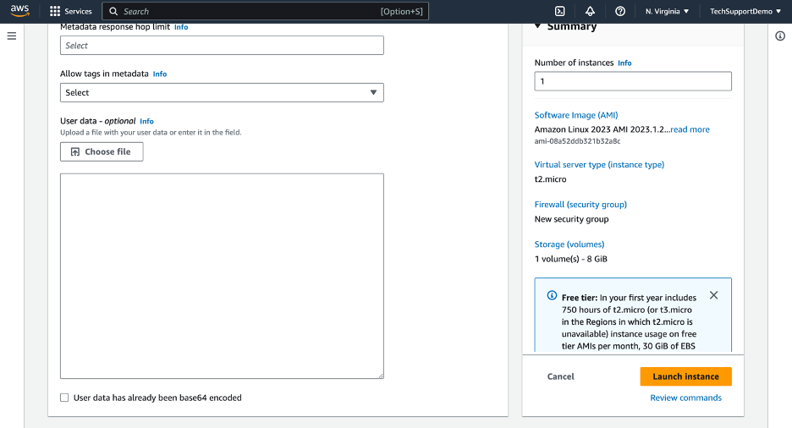
Here’s a structured troubleshooting checklist for Amazon EC2 user data (Linux/Windows):
🔎 Common Issues
- Missing software/configurations: Instance launches but user data script effects aren’t applied.
- Initialization failures: Instance stuck in pending or unusually slow to start.
- No log output: User data script doesn’t produce logs.
🛠️ Troubleshooting Recommendations
- Check script syntax
  - Look for typos, invalid commands, or incorrect paths.
  - Access via EC2 Console → Actions → Instance settings → Edit user data.
- Understand modification rules
  - User data runs only at first boot by default.
  - To re-run after restart, configure cloud-init or Windows Launch settings.
  - Must stop instance before editing user data.
- Review system logs
  - Linux: /var/log/cloud-init-output.log
  - Windows: C:\ProgramData\Amazon\EC2-Windows\Launch\Log\UserdataExecution.log
  - Console path: Actions → Monitor and Troubleshoot → Get System Log.
- Validate AMI compatibility
  - Bash/shell scripts → Linux AMIs.
  - PowerShell scripts → Windows AMIs.
  - Confirm AMI supports directives used in script.
- Test before production
  - Run scripts in a staging environment.
  - Ensure dependencies (packages, repos, permissions) are available.
⚡ Quick Tips
- Use #!/bin/bash or #ps1 headers to clarify script type.
- Redirect output to log files for easier debugging.
- Ensure network access if script downloads packages/code.
- For repeated execution, configure cloud-init directives or Windows Task Scheduler.

